**FOOD SUPPLY MANAGEMENT SYSTEM USING BLOCK-CHAIN TECHNOLOGY**

**V. SAI KRUPA, A. VANI VATHSALA**

*CVR College of Engineering, Hyderabad, Telangana, India*

*Department of Computer Science and Engineering*

[*v.saikrupa9@gmail.com*](mailto:v.saikrupa9@gmail.com)

[*atlurivv@yahoo.com*](mailto:atlurivv@yahoo.com)

***Abstract: The food supply chain consists mainly of Farmer, distributor, retailers and end users. In the current scenario, food supply chain manufacturers benefit as much farmer and consumer lose. Multiple web-based food supply management systems are now widely used. These FSMs are unsafe and vulnerable to data manipulation. Even when sensitive data and a password are secured, they can be changed if the user's password has been compromised, which means conventional recording methods are vulnerable. Block chain has a decentralized system that transparently stores and secures transactions and there is no central authority for transactions occurring. A model is applied using the central Block Chain technology to securely store transactions in the food supply chain. Anyone in the linked network can easily access these transactions. And if the data is corrupted, it can be easily identified.***

***Keywords*: *Block-chain, Food Supply Chain, Consortium, Data Tampering, Security.***

# INTRODUCTION

# Block chains are known to contain transactional data within their decentralized data structures, which constitute a collection of closely linked blocks. In order to achieve ledgers accuracy, data integrity, auditability, non-repudiation and authentication as part of the basic security principles asymmetric cryptography and distributed consensus algorithms are implemented. The distributed and decentralized existence of the block chains renders them unchangeable because transactions can not be tampered with until they are formally checked by the network's peers and registered in the chain database. At the same time, durability and robustness are elements that make block chains a secure, transparent, trustworthy network for peers. This is largely because block chains can enforce transactions and payments without an intermediary, essentially disrupting the functioning of conventional companies to date.

# Data and transactions are usually processed in paper and digital formats in every food organization. In this current environment, such storage methods are obsolete by the numerous regular threats. Regardless of how we protect the data by passwords, they also appear to be abused. A block chain is a booklet without the influence of a central authority. It is a technology that enables individual entities to function with trust and accountability.

# This model has been developed and implemented that uses the block chain in a consortium network form to store different data types in blocks. Anyone on the network can display and manipulate this data, but they cannot alter it.

# This specific model is not incorporated in the actual block chain, but its technology is used and applied in the company.

# *FSM Impact*

# The details about the original price of food products sold by farmers cannot be reviewed by customers or retailers. This is easy to exploit. This is the biggest downside to modern record formats. There is also a problem in preserving those information, not just losing the originality of the documents.

# This particular Block-chain implementation will solve the following problems:

# Data storage: Blocks in the block chain do not become a physical object that deteriorates over time.

# Data access: Block chains have a decentralized architecture such that the data in the system is accessed by means of hacking, which is a commonly used way to link data within a distributed network.

# Data manipulation: As Block-Chain is protected by Hashing which uses DES Algorithm, it securely stores the data and makes it flawless.

# To solve these issues, we've introduced a innovative concept using block chain Technology, a peer-to-peer system to hold records, incorporating encryption methods such as digital signatures to guarantee confidentiality, data protection and simple record storage that ensures that data are not manipulated at any specific time. As digital signatures are created by a hashing technique using private and public keys, third parties can not alter transactions created by the owner. So block chain uses a Consensus algorithm, which is a tolerant fault mechanism and used in a framework that overcomes the limitations of conventional record keeping methods to reach the agreement on a single data value.

**II. RELATED WORK**

The authors [1] have an idea about the System for Product Ownership Management (POMS). The RFID-attached RFID products product ownership system (POMS) for anti-counterfeits that can be used in the post-supply chain. To that end, we use Bitcoin's block chain idea that anyone can check the proof of balance. The proposed POMS enables a customer, although not owned by the seller, to refuse the purchase of counterfeits even with genuine RFID tag information. We have a proof-of -concept experimental system using a decentralized block-chain application platform, for example When products reach the end of the supply chain and are shown in retail stores, the genuineness is no longer guaranteed, as anyone with an RFID reader can query and clone tags information. Ethereum has evaluated its cost performance. Therefore, even when the tag information is cloned within the post-supply chain, it is important to develop anti-counterfeit systems.

In [2] authors have an idea about the impact of blockchain technology on agriculture and the food supply chain, present ongoing projects and initiatives and discuss the general implications, challenges and potentials of these projects in critical terms. Our findings indicate that blockchain is a promising technology to create a transparent supply chain with many ongoing initiatives on various food products and food-related issues but there are still a great many barriers and challenges that hinder its wider popularity among farmers and systems.

Authors in [3] have an idea of a detailed analysis of the fit in the supply chain industry. It defines the basic elements of blockchain which affect the supply chain such as scalability, efficiency, consensus mechanism, confidentiality, location evidence and costs and the effect blockchains will have on the supply chain industry. The discussion of the balance between the cost, throughput and validation time of consensus continues with a suggested high-level architectural approach and concludes with a discussion on required changes and challenges to the in vivo implementation of blockchains in the supply chain industry. While the technical characteristics of modern blockchains can effectively facilitate the use of supply chains, the various challenges still present us with a broad range of changes and further research efforts to achieve a global, productive blockchain for the supply chain industry.

**III. MAIN MODULES AND PARTICIPANTS INVOLVED IN FSM NETWORK**

There are three working modules in FSM and they interact by sharing transactions. It is: farmer, distributor and customer. Here, Farmer will register and add products to the network. The distributor registers in the network, purchases the farmers' products and sells them with a minimum margin to the customer. The customer also registers in the network and selects and purchases the product. All these activities are transacted.

Every node in the network is involved in the block chain. There are four participants who communicate as shown in fig 1

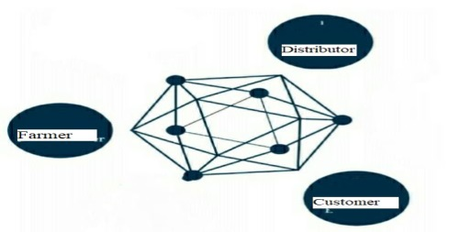

Fig 1: Participants involved in Consortium Network.

**IV.** **TRANSACTION MECHANISM**

The block chain is a distributed network which is based on a single data value consensus approach across a system. Transactions cannot simply be stored in a distributed network.

They must go through a transaction mechanism step-by - step procedure. It is definable in five steps, as shown in figure 3: Transaction Encryption, Transaction Decryption, Block Creation, Block Authentication and Block Propagation.

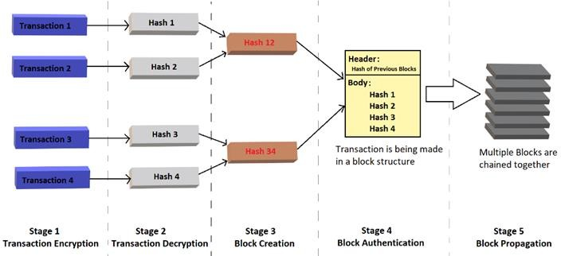

Fig 2: Transaction Mechanism in FSM

1. *Transaction Encryption*

The data holder will begin the transaction by entering the details of the public key of the receiver, the address of the receiver and the transaction value. After initiating the transaction, the digital cryptographic signature of the sender authenticates the stored transactions would be encrypted.

1. *Transaction Decryption*

The signed transaction is sent to the network and received via all network nodes. Then the message is authenticated by digital signature decryption. In addition, it is sent to the outstanding transaction pool where it waits for a block to be formed.

1. *Block Acknowledgement*

Any node on the network initiates a block by merging all other decrypted transactions in the waiting state. When the block is generated, it is transmitted for authentication to each node on the network.

1. *Block Authentication*

After the block copies are obtained, the nodes start an interactive process to validate them and communicate with each other to search for a single system value. However, if they do not share the same data value because of network considerations, there might be a gap between divisions of Block-chain. Therefore, a consensus on block validity between all nodes must be achieved.

1. *Block Propagation*

When a block has been authenticated, it is documented as a confirmed block in the network. The next block will be connected to the block checked recently. Moreover, these two blocks form a chain and are broadcast on the network to spread further blocks as a validated version of the block chain.

1. **IMPLEMENTATION OF FSM**

# Because the Food Supply Chain Management System (FSMS) is implemented in a consortium network using block chain technology, it operates in a similar way to the true block chain and needs no cryptocurrency like bitcoin. The working of the FSMS is shown in the following algorithm. The procedure begins from Input information given by the participant to the final block chain creation.

# A. Algorithm

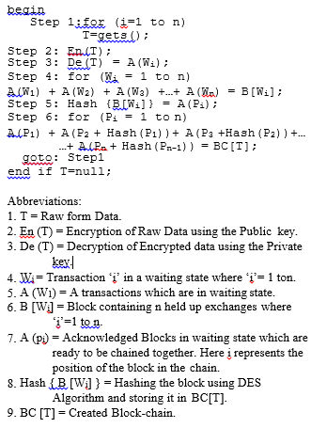

The user interface uses the command gets to access the user's input. The raw data is then encrypted using a public key and is transmitted through the network. After obtaining the encrypted data, it is now decrypted by the private key and stored in a pool of waiting transactions.

In the next stage, all waiting transactions are now grouped into one block. The block that contains any transactions is now hashed with the DES algorithm, and the block is now called a known block. This known block is now stored in a separate pool of ready-to-chain blocks.

All known blocks are now chained together using the hashes of their previous blocks that form the block chain. This chain is distributed until the transactions take place.

Blockchain's monitoring ability of ownership logs can be used to address issues including food theft, inefficiency in the food supply chain and food traceability within the current food system. Blockchain framework ensures that any individual in the food value chain produces and exchanges data points securely to establish an accountable, traceable system.

**VI.** **RESULTS AND DISCUSSION**

Each of the modules uses the user's input and stores the data as blocks. These blocks are chained together and a chain is propagated. The data in these blocks are clear and can be accessed from all other nodes participating in the network. Any node may display all nodes' data and transactions, but these nodes are not able to alter these blocks. The transactions will therefore be clear and deceptive facts.

Consider a module, which stores food information on a blockchain as shown in Fig 4 as input from the farmer.

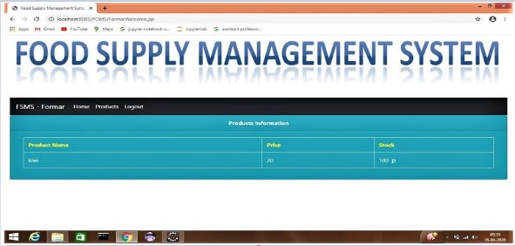

***Fig 3: Front End Of Farmer Module***

Now food product details has been add in the block chain.

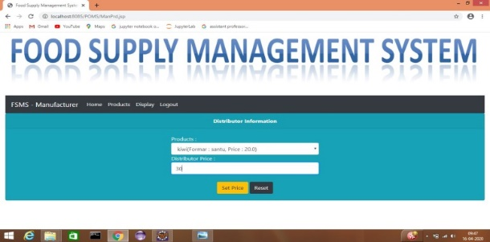

***Fig 4: Front End Of Distributor Module***

Customer selecting the product on the block chain and purchasing from the network.

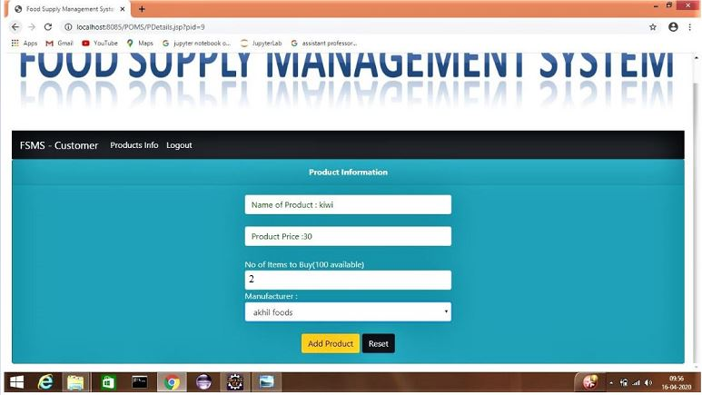

***Fig 5: Customer Module***

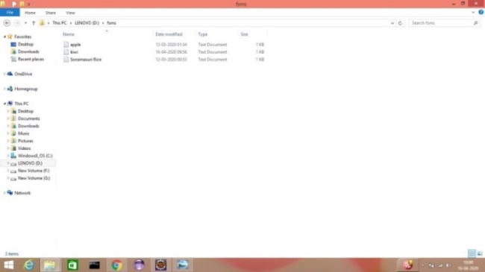

***Fig 6: Block Creation***

These are the blocks in which transactions are processed and linked to hashes. This process of chaining is continued until the transactions take place. Our blockchain is propagated in this way.

If a user wishes to display the data, he may directly open the block and access the transaction as shown in Fig 8.

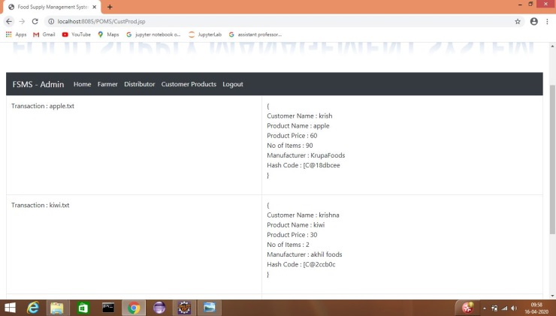

***Fig 7: Data Accessing***

**VII. CONCLUSION AND FUTURE WORK**

The block chain has a decentralized architecture and is able to revolutionize multiple sectors in addition to the food industry. A block chain Food Supply Chain Management Framework was developed in this paper using an intelligent contract to ensure that every single transaction occurring inside the framework is safely and securely even in cases of data interference. -- Transaction of the modules linked to one another using hashes is easy and can be seen by everyone in the network.

The transactions in this food supply chain management system can be made, but no one, including the data owner, can change them as if they were a genuine block chain which ensures that there is no opportunity of information being modified. All transactions of each module are transmitted to the network's active nodes, which means that every module contains each node-hazh pair. Whenever the data owner attaches a new transaction, it is also broadcast and chained to existing blocks on the network.

Accordingly, this model takes note, with the help of Block chain technology, of conventional record keeping problems and their information security concerns. Since the model depicted is an important improvement in how information and transactions are protected using Block Chain Technology, the necessary changes can also be updated and refreshed.

**VIII. REFERENCES**

***[1] Kentaroh Toyoda1, (Member, IEEE), P. Takis Mathiopoulos2, (Senior Member, IEEE), Iwao Sasase1, (Senior Member, IEEE), and Tomoaki Ohtsuki1, (Senior Member, IEEE). A Novel Block chain-Based Product Ownership Management System (POMS) for Anti-Counterfeits in the Post Supply Chain.***

***[2] Andreas Kamilaris1,2, Agusti Fonts1 and Francesc X. Prenafeta-Boldύ11 GIRO Program, IRTA Torre Marimon, E-08140 Caldes de Montbui, Barcelona, Spain 2 Research Centre on Interactive Media, Smart Systems and Emerging Technologies (RISE), Nicosia, Cyprus.The Rise of Blockchain Technology in Agriculture and Food Supply Chains.***

***[3] Antonios Litke 1,* , Dimosthenis Anagnostopoulos 2 and Theodora Varvarigou 1 1 Electrical and Computer Engineering school, National Technical University of Athens, 157 73 Athens,Greece;*** [***dora@telecom.ntua.gr***](mailto:dora@telecom.ntua.gr) ***2 Department of Informatics and Telematics, Harokopio University of Athens, 176 76 Athens, Greece;*** [***dimosthe@hua.gr***](mailto:dimosthe@hua.gr) ***Blockchains for Supply Chain Management:Architectural Elements and Challenges Towards a Global Scale Deployment.***

***[4] Z. Zheng, S. Xie, H. Dai, X. Chen, and H. Wang, in Proc. IEEE Int. Congr. Big Data (BigData Congr.), Jun. 2017, pp. 557–564. “An overview of block chain technology: Architecture, consensus, and future trends’’[Online] Available: http://ieeexplore.ieee.org/document/ 8029379/***

***[5] Caro, M.P., M.S. Ali, M. Vecchio, and R. Giaffreda. 2018. "Blockchain-based traceability in Agri-Food supply chain management: A practical implementation." IoT Vertical and Topical Summit on Agriculture-Tuscany (IOT Tuscany). IEEE. 1-4.***

***[6] “Block chain Applications: A Hands-On Approach (2017)” Author: ArshdeepBahga, Vijay Available: https://books.google.co.in/books?id=M7sanQAACAAJ&redir_esc=y&hl=en.***

***[7] Feng Tian 2017 International Conference on Service Systems and Service Management. A Supply Chain Traceability System for Food Safety Based on HACCP, Block chain & Internet of Things.***